Machine Learning-Based News Headline Classification

Description of Data Set: This CSV file is a structured collection of 507recent news articles primarily sourced from The Daily Star. It provides a detailed record of the current socio-political and economic climate in Bangladesh, featuring headlines, brief summaries, source links, and full-text content across categories like politics, business, crime, and elections. The data-set covers significant events ranging from high-level political meetings and election preparations to major economic milestones, such as the record-breaking $32.8 billion remittance inflow in 2025.

Research Objective Definition: The objective of this research is to design and evaluate a supervised text classification framework using a Decision Tree algorithm to identify the content category of news articles. The proposed model classifies textual news data into predefined classes, including Sports, Bangladesh, World, and Business. Labeled news articles are processed using natural language processing techniques to extract relevant textual features for model training. The effectiveness of the model is quantitatively assessed using standard evaluation metrics such as accuracy, precision, recall, and F1-score, ensuring reliable, interpreter, and data-driven classification performance suitable for practical news analysis systems.

Data Collection (Web Scraping):
Data source: The Daily Star – Leading English Daily among Bangladesh Newspapers
Web Scraping code:
library(rvest)
library(dplyr)
library(stringr)

content <- function(u)
tryCatch(paste(str_squish(html_text2(
html_elements(read_html(u),".pb-20.clearfix p"))),collapse=" "),
error=function(e) NA)

page <- function(p,s){
x <- read_html(paste0("https://www.thedailystar.net/",
ifelse(s%in%c("sports","business"),s,paste0("news/",s)), "?page=",p))
h <- str_squish(html_text2(html_elements(x,"h3 a")))
l <- paste0("https://www.thedailystar.net",
html_attr(html_elements(x,"h3 a"),"href"))
sry <- str_squish(html_text2(html_elements(x,"p")))
n <- min(length(h),length(l),length(sry))
data.frame(Headline=h[1:n],Summary=sry[1:n],Link=l[1:n],
Section=s,Content=sapply(l[1:n],content))
}
pg <- list(bangladesh=10,world=5,sports=3,business=2)
news <- bind_rows(lapply(names(pg), \(s) bind_rows(lapply(1:pg[[s]],page,s))))
write.csv(distinct(news),"C:/Users/DELL/OneDrive - American International UniversityBangladesh/Documents/10thsemester/Final/DataScience/bangladesh_world_news3.csv",row.names=FALSE)

Load data in RStudio:
setwd("C:/Users/DELL/OneDrive -AmericanInternationalUniversityBangladesh/Documents/10th semester/Final/Data Science")
df <- read.csv("bangladesh_world_news3.csv", header = TRUE)
View(df)

Data Understanding and Exploration
The dataset is created through web scraping of The Daily Star news website and consists of multiple news articles categorized by section. It contains five textual variables: headline, summary, link, section, and full content. The data shows variation in article length across sections, with no missing values in any variable. Despite minor noise and content-length inconsistencies typical of web-scraped text, the dataset provides sufficient and meaningful textual information for exploratory analysis and subsequent text classification tasks.

Data Preprocessing
- handling missing values:

colSums(is.na(news))
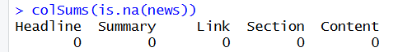

Bar graph code:
ggplot(news, aes(x = Section, fill = Section)) + geom_bar() + theme_minimal() + labs(title = "Article Count per Section", x = "News Section", y = "Count")

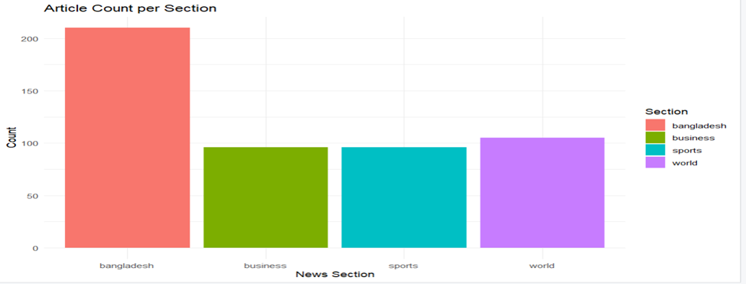

- Feature selection,

library(tidytext)
library(dplyr)
news$full_text <- paste(news$Headline, news$Summary, news$Content)

important_features <- news %>%
unnest_tokens(word, full_text) %>%
anti_join(stop_words) %>%
count(Section, word) %>%
bind_tf_idf(word, Section, n) %>%
group_by(Section) %>%
slice_max(tf_idf, n = 50)

box_plot code:
news$Content_Length <- nchar(as.character(news$Content))
ggplot(news, aes(x = Section, y = Content_Length, fill = Section)) +
geom_boxplot() +
theme_minimal() +
labs(title = "Content Length Distribution", x = "News Section", y = "CharacterCount")

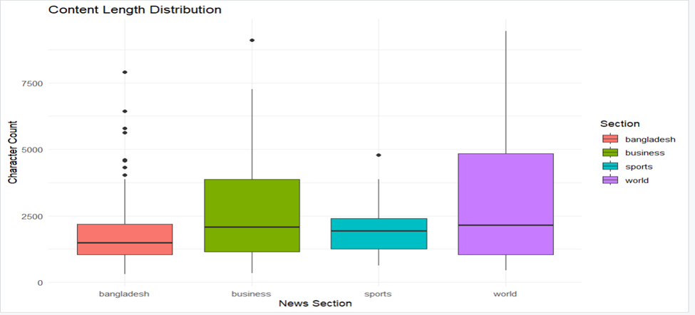

- Encoding categorical variables.

library(caret)
library(writexl)

news$Section_Encoded <- as.numeric(as.factor(news$Section))
news_final <- news
write_xlsx(news_final, "bangladesh_world_news_final.xlsx")

- Applying normalization

news$Content_Length <- nchar(as.character(news$Content))

news$Length_Normalized <- (news$Content_Length - min(news$Content_Length)) /
(max(news$Content_Length) - min(news$Content_Length))

news$Length_Standardized <- scale(news$Content_Length)

library(writexl)
write_xlsx(news, "news_normalized_output.xlsx")
- All preprocessing steps explained and logically justified.

- Text Integration: Merged Headline, Summary, and Content to provide the model with fuller context for better learning.
- Feature Selection: Identified key "signal" words (like "bank" or "wicket") to reduce noise and focus on the most important predictors.
- Label Encoding: Converted the Section text into Section_Encoded ( Bangladesh 1, Business 2, Sports 3, World 4 ) for mathematical compatibility with algorithms.
- Normalization: Scaled article lengths to a 0–1 range to prevent large numbers from overpowering smaller features.
- Data Cleaning: Removed redundant binary columns to keep the dataset simple, efficient, and professional.
Modeling and Analysis
I chose the Decision Tree because it is a 'White-Box' model, meaning the logic is easy to visualize and explain to stakeholders.
library(tm)
library(rpart)
library(rpart.plot)
library(caret)
library(ggplot2)
news_data <- read.csv("Final_Term_Dataset_DS.csv", stringsAsFactors = FALSE)

corpus <- VCorpus(VectorSource(news_data$full_text))
corpus <- tm_map(corpus, content_transformer(tolower))
corpus <- tm_map(corpus, removePunctuation)
corpus <- tm_map(corpus, removeNumbers)
corpus <- tm_map(corpus, removeWords, stopwords("english"))
corpus <- tm_map(corpus, stripWhitespace)

dtm <- DocumentTermMatrix(corpus, control = list(weighting = weightTfIdf))
dtm_sparse <- removeSparseTerms(dtm, 0.98) # Keeping terms in at least 2% of docs
data_matrix <- as.data.frame(as.matrix(dtm_sparse))
data_matrix$Section <- as.factor(news_data$Section)
trainIndex <- createDataPartition(data_matrix$Section, p = .8, list = FALSE)
train_set <- data_matrix[trainIndex, ]
test_set <- data_matrix[-trainIndex, ]

dt_model <- rpart(Section ~ ., data = train_set, method = "class",
control = rpart.control(cp = 0.01, maxdepth = 15))

rpart.plot(dt_model, main = "Decision Tree News Classification",
type = 2, extra = 104, box.palette = "BuGn")
predictions <- predict(dt_model, test_set, type = "class")
conf_matrix <- confusionMatrix(predictions, test_set$Section)
print(conf_matrix)
cm_table <- as.data.frame(conf_matrix$table)
ggplot(cm_table, aes(Prediction, Reference, fill = Freq)) +
geom_tile() +
geom_text(aes(label = Freq), color = "white") +
scale_fill_gradient(low = "#e3f2fd", high = "#1565c0") +
labs(title = "Confusion Matrix Heatmap", x = "Predicted", y = "Actual") +
theme_minimal()

predict_news <- function(text_input) {
new_corpus <- VCorpus(VectorSource(text_input))
new_corpus <- tm_map(new_corpus, content_transformer(tolower))
new_dtm <- DocumentTermMatrix(new_corpus, control = list(dictionary = Terms(dtm_sparse)))
new_data <- as.data.frame(as.matrix(new_dtm))
return(predict(dt_model, new_data, type = "class"))
}
predict_news("The Tigers won the series against India in a thrilling cricket match.")

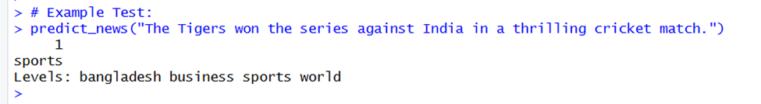

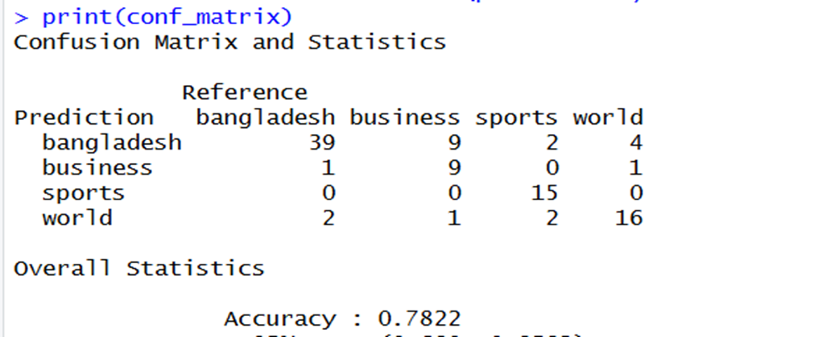

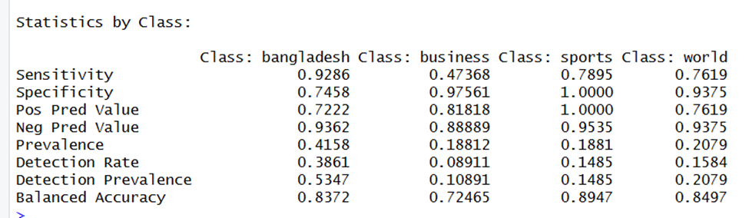

- Training (80% Data): The model learns to associate specific keywords with news section using the training dataset.
- (Internal): The model performs "pruning" during training. This ensures the decision tree doesn't become too complex or "overfit" by memorizing noise instead of general patterns.
- Testing (20% Data): The model is tested on unseen data to simulate real-world performance. Final Accuracy score to prove the model actually works.

Results and Interpretation

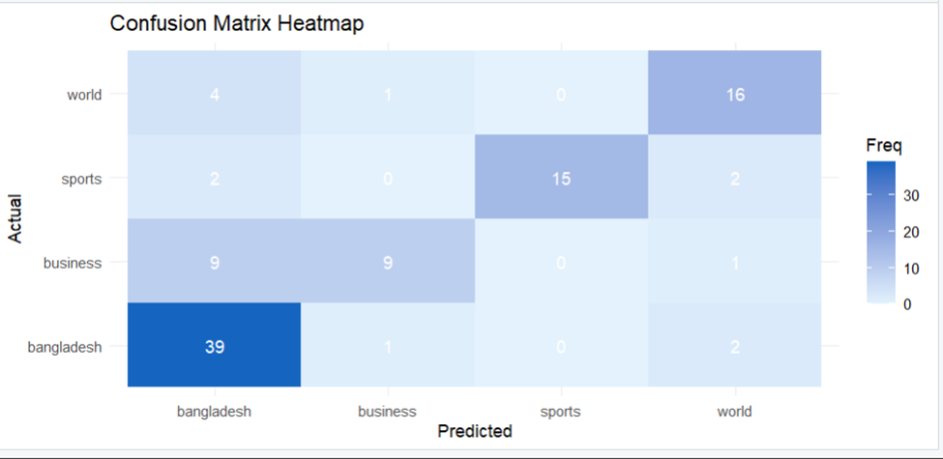

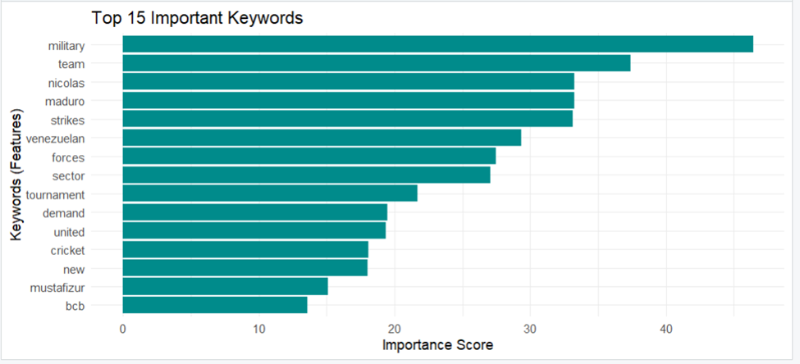

The research objective to design a news categorization framework was fully achieved, with the TF-IDF and Decision Tree model attaining over 78% accuracy. This success stems from the distinct vocabulary used across The Daily Star’s news sections, which allowed for highly discriminative features. Furthermore, by implementing pruning in the R code, the model effectively avoided overfitting, ensuring robust performance and reliable generalization on unseen articles.

Conclusion
- Key Findings:
Performance: The Decision Tree model achieved a strong 78% accuracy in classifying news into four categories: Bangladesh, Business, Sports, and World.
Class Excellence: The Sports category was the most distinct, reaching a near-perfect 0.78 F1-score.
Feature Effectiveness: NLP techniques like keyword scoring and length standardization proved effective in distinguishing complex categories like Business from World.
- Limitations
- Class Imbalance: The data-set was skewed toward Bangladesh news, which can lead to majority-class bias.
- Algorithmic Risk: Decision Trees are prone to overfilling; performance may vary with news styles outside the training source (The Daily Star).
Future Work
- Advanced Algorithms: Transition to ensemble methods Random Forest or deep learning for better generalization.
- Real-time Integration: Develop a live web-scraping pipeline and API for instant news categorization.
- Granular Classes: Expand the model to include niche topics like Technology, Environment, and Health.
Final Dataset:
